Alien Tag

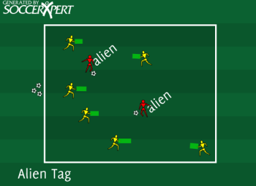
Drill Objective:
This is a fun game for 2 through 4-year-olds. This will focus on agility, vision, and awareness, but best of all, it's fun.

Drill Setup:
- Create an area about 20X20. Call this space Mars.
- Two players will need balls. They will be the aliens.
- The remaining players are inside the grid with a pool noodle each (without a ball). They are the spaceships.

Drill Instructions:
- Have the spaceships hold either end of the noodle to create the front of their spaceship. Their goal is to avoid the aliens who are kicking space rocks (soccer balls) at them.
- Aliens have a ball, and the coach should have a few spare balls if the "space rocks" are hurled into space.
- If an alien hits the spaceship (any part of the player) with the ball, the spaceship must spin out of control and crash to the ground.
- For the first iteration, let the spaceships get back into the game after some minor repairs (5 jumping jacks or something like that).

Drill Coaching Points:
- This game should be fun for the kids. The coach can improve their experience by making noises, crash sounds, or yelling "heeeeeelp" when a ship goes down.
- The spaceships should have their heads up and looking around to avoid the aliens.
- Make sure the players move by telling making them crash if they aren't moving.
- The aliens must dribble the ball and aim for the space ships so this will be a good start to controlling the ball and shots/passes.
- Make it fun for the kids.

Drill Variations
- When a spaceship goes down, make the space ship driver become an alien. The last person left driving the spaceship is the Jedi.

